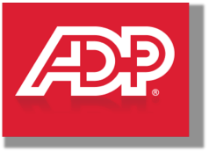
ADP 2017 Pro Client Conference
Protocol
Prepared by Jonathan Yardley

Background & Purpose

π Payroll Innovation

ADP’s NextGen Payroll initiative aims to re-imagine and build revolutionary global payroll solution that provides an unprecedented level of transparency, access, speed, and ease of use to payroll practitioners, managers, finance professionals, compliance experts, and employees to insure that pay works, everyday, for everyone.

Our goal is to get direct client feedback on key NextGen concepts of “Policies” and “Interactive Register”. We will expose the clients to these concepts and gather feedback on concept acceptance, understanding and clarity of our communication of the concepts. This is a building block for future research efforts to validate these core concepts.

The objective of the Protocol is to provide a loose outline of the conversation for the sessions. Questions are not meant to be read word for word, but rather a guide to ensure all relevant points are discussed during the time allotted.
1. Intro:
First off, thank you for agreeing to meet with us today. My name is Jon and I am a researcher within Payroll Innovation/NextGen here at ADP. Today I’d like to spend about an hour talking with you. Before we get started, I would like to remind you that we are recording today’s session, I hope that’s ok.
Today we’re going to spend some time talking about you and your work life, and I am going to be asking you about how we can build a better experience for you, your company when it comes to Payroll and HCM.
This is in no way a test; the only “right” answers are your opinions, so I hope you will share your thoughts openly with me.
Do you have any questions before we get started? Great!
User Background
Tell me a little about yourself, your company and your role with it?
- Your 90 second elevator pitch (prompt as necessary)
- What kind of person is successful in your kind of work?
- What skills are required to do your job?
- How do you stay up to date and get information on your industry and profession?
- What ADP products do you personally work with?
- What are the top 3 most annoying, frustrating part of your work when it comes to Payroll and ADP specifically?
- What are the most enjoyable parts of your work
Any questions for me before we begin?
Policies- Setup
- Have you experienced an Implementation of a Payroll or other system (ADP or other)?
  - How would you describe that process?
    - Adjectives, emotions etc.
- Are you familiar with ADP’s use of “Paycodes”? Can you describe them to me?

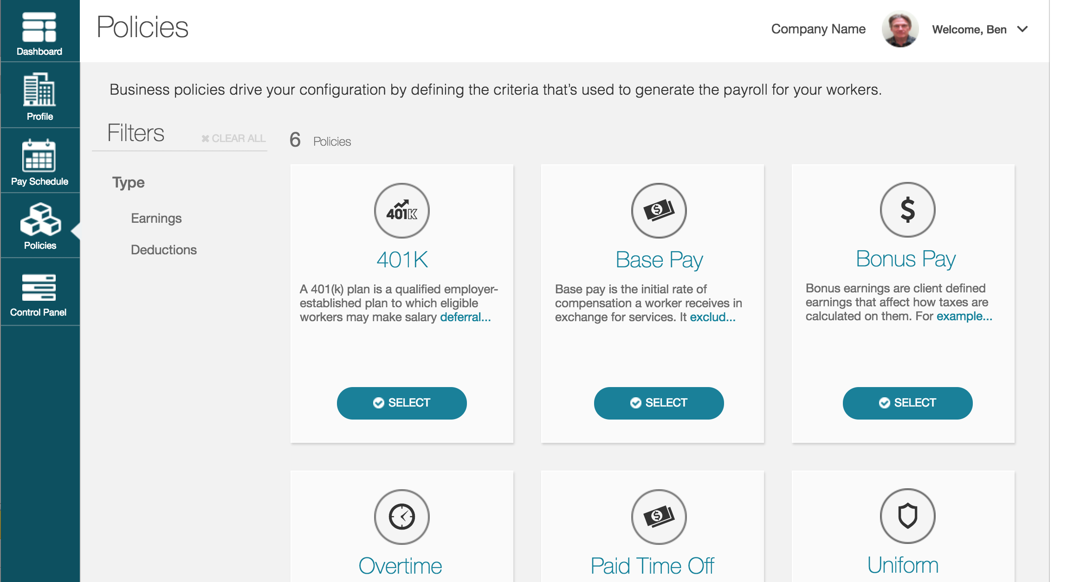
Free Explore Policies

- I want to show you a mock up of a screen and have you tell me what you are looking at and what you think only based on what you see on the screen that you are able to do. Please talk me through what you see, what you like or have questions or concerns about.
  - Probe and coach as necessary
  - What is the scenario you imagine doing this in?
  - Would you be doing this by yourself or with someone else with you?
  - How well does this screen communicate the concept of Policies

Establish 401K Policies (2)
OK, now let’s try something a little different together. Let’s talk briefly about 401Ks and then I would like to ask you to establish (2) 401K policies and give me your feedback on the process we are building.
- To give you a little context – we are envisioning the onboarding process to be a “shared” experience between our ADP Implementers and our clients. Please imagine I am the ADP Implementer and we are working together to establish your payroll configuration.
- Let’s begin by you telling me where would you go to configure your 1st 401K Policy.
  - Talk me through what you are doing?
  - Probe as necessary
  - Lather, rinse, repeat
Policies Fin

FIT Drill Down

OK, now let’s look at a different prototype together. Before we do can you please talk to me about the most common scenarios where people come to you asking for help about their paycheck?

- Collect as many scenarios as possible – this may vary by User’s role re: payroll
- How do you currently look at Federal Income Tax calculations for an individual employee
  - What ADP resources
  - What external resources
  - Analog tools used?
Scenario Presentation
New hire employee Clara Clifton has called in and is questioning her Federal Income Tax calculation. With this screen how would you help her?

